Software Pricing

**2019**

***RASHMI R***

***SUPRAJA S***

10/10/2019



* To introduce the fundamentals of Software Pricing and Costing.
* To explain software productivity metric.
* The goals that guide your business in setting the **cost** of a product or service to your existing or potential consumers.
* Some examples of **pricing objectives** include maximizing profits, increasing sales volume, matching competitors' **prices**, deterring competitors – or just pure survival.
* To deliver useful information about Software Cost benefit analysis.
* To understand the reasons why the price of the software may not be directly related to its development cost.
* To be an ultimate guide for the marketing strategies involved in the cost estimation of a particular product/software.
* To understand the factors that merely affects the price of the software.
* The factors in detail which can be studied and implemented in the real – life application during the cost estimation of the software.
* **Classically, the price of a software product to a customer is simply the cost of development plus profit for the developer.**
* **However the relation between the project cost and the development cost is not so simple.**
* **Software pricing must take into account a group of factors.**
* **Estimates are made to discover the cost, to the developer, of producing a software system.**
* **There is no simple relationship between the development cost and the price charged to the customer.**
* **Broader organizational, economic, political and business considerations influence the price charged.**
* **Software pricing is influenced by**
* **economic considerations**
* **political considerations and**
* **business considerations**

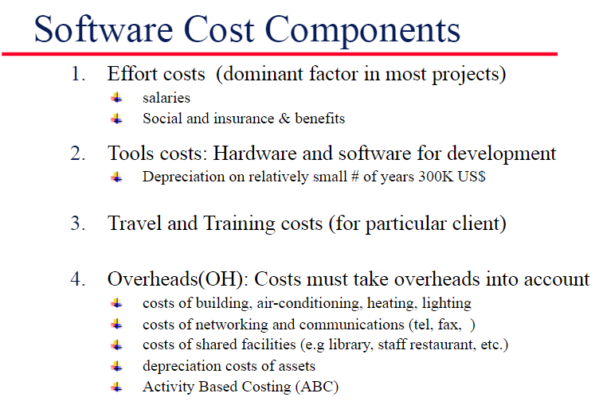

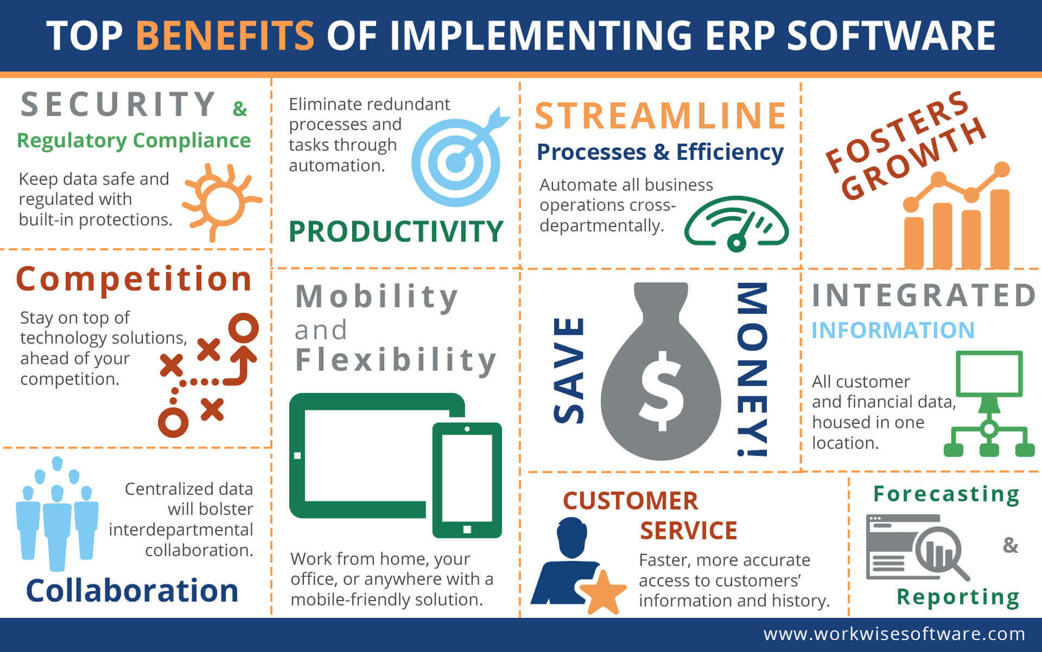

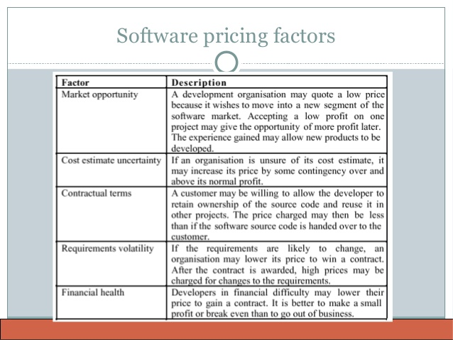

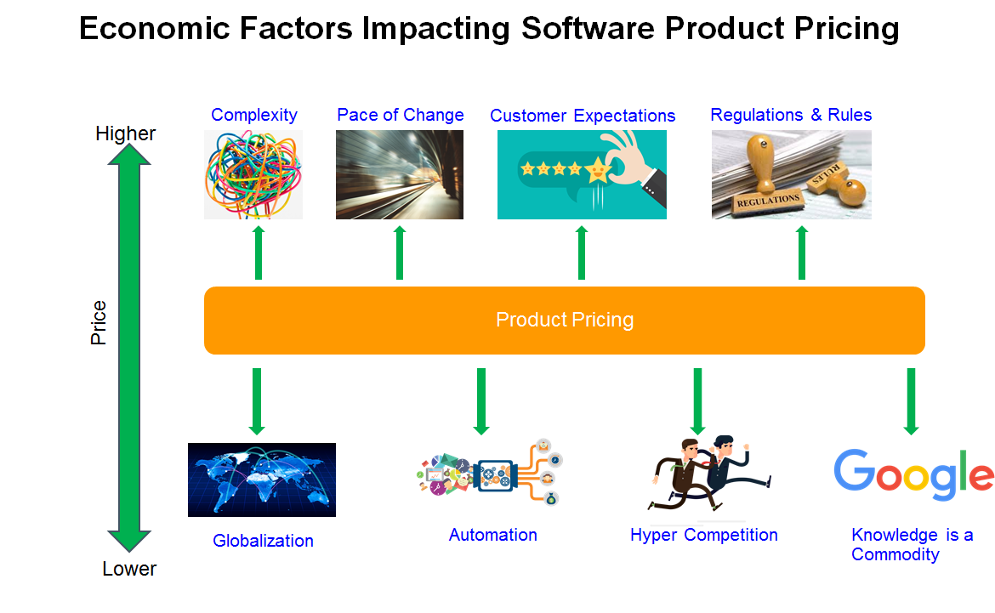

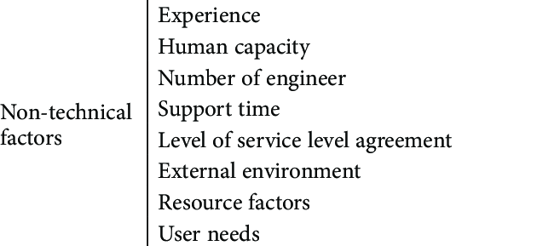

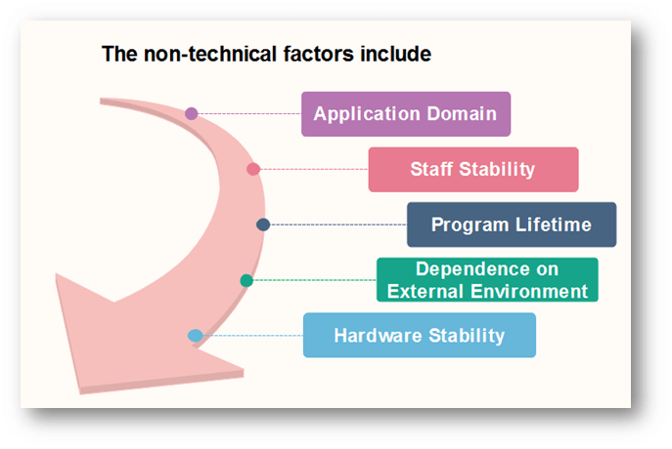

* **Having a price strategy is a very healthy action to take for business of all sizes.**
* **Hence, an organization in the software market establishes its stability by the effective use of software pricing technique.**
* **The significance of software cost estimation is hopefully delivered in an appropriate manner to the viewers of this presentation.**
  + **Google web**
  + **Google images**
  + **Wikipedia**
  + **LinkedIn**
  + **Others……….**

**Thank You**